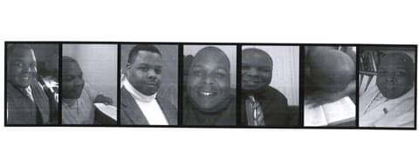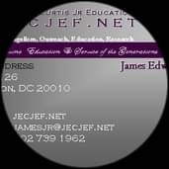
󱘄
󱘄
󰛼
James E Curtis Jr.
󱠂
AAHEA Branch Director 2022-, AAHEA󰟝
󱚸 Director 2021-, at American Association for Higher Education
󱚸 Internet Graduate Research Institute
󱚸 Former economist assistant at FDIC
Studied Economics at Graduate School,
󱜧 Ohio State University Studied Economics at Ohio State
󱜧 University, Columbus, OH
󱜧 Studied Economics at Howard University
󱜧 Studied Economics at Rutgers University
󱜧 Went to Calvin Coolidge
󱜧 Went to Gar-field High
󱜏 Lives in Washington D.C.
󱘛 From Columbus, Ohio
󱚷 Single
󱤂 getordained.org/find-a-minister/38634
󱤂 jecjef.net/6.html
󱤂 YouTube.com/JamesCurtisJr
󱤂 Jecjef.net/ENDURINGFAITH.html
󱤂 igri.academia.edu
󱜳󱙇 .... _{James E Curtis Jr.}
󰛼
Friends See all
3 friends

D... Stephen R. Barnhart ... Christopher Campbell ...
󱘋 Photos 󱝤 Life events
Posts
󱘋 󰘋
Photo 󱘛 󱘕 Life Event
James E Curtis Jr.

2021-2022 Visiting Professorship, , (Adjunct Professor, , candidate),
2022 Visiting Professorship, Religious Studies, Summer 2022,
2022-2023, Visiting Professorship,
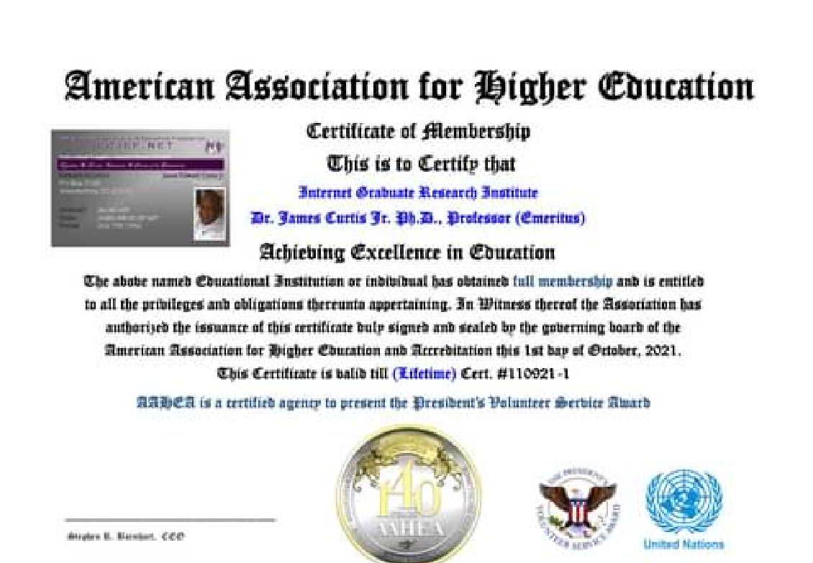
󱜳 James E Curtis Jr.

........ James E CurtisJr. ..(H.dsw.) Dr. James Curtis, Jr. Ph.D.(advanced) Transcriptmaker™ transcript of Dr./6/2022, The Honorary doctorate of social work Nov 29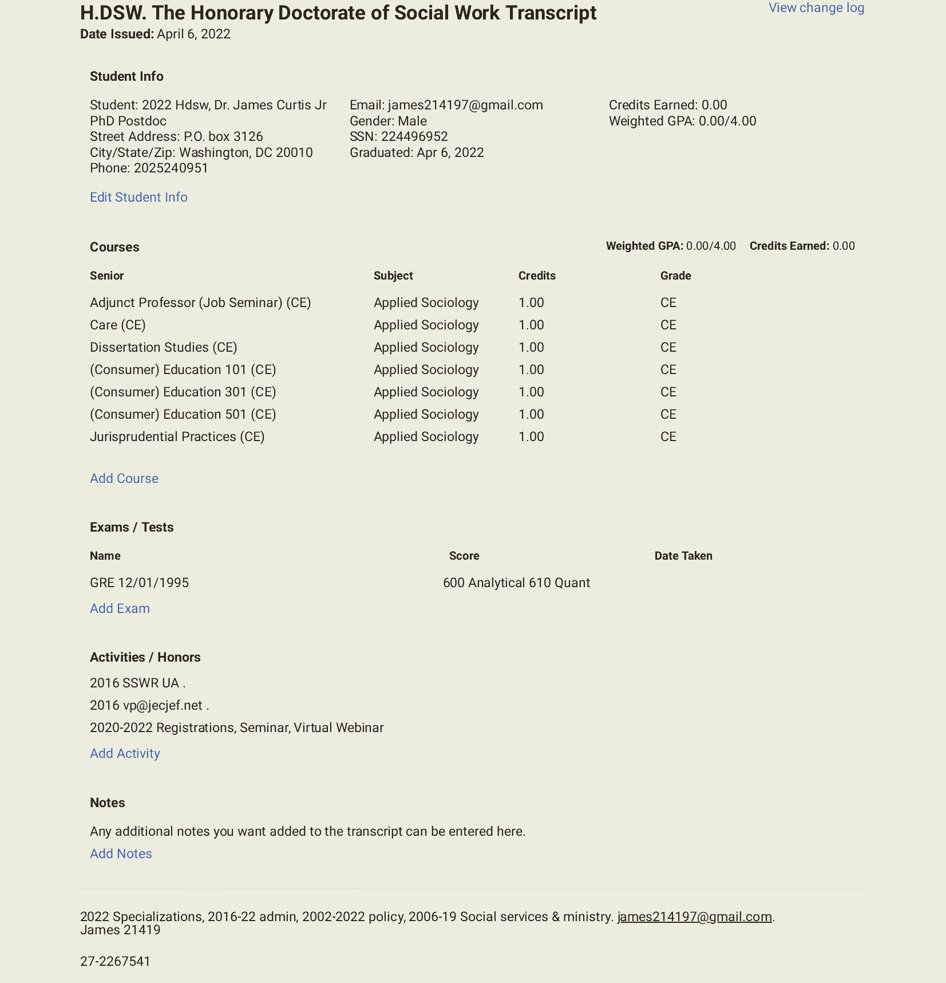
1
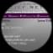 James E Curtis Jr. 󰤧
The Honorary doctorate of social work transcript of Dr. James Curtis, Jr. PhD.󰤥Nov 29󰞋󰤊 󰤦 󰟝
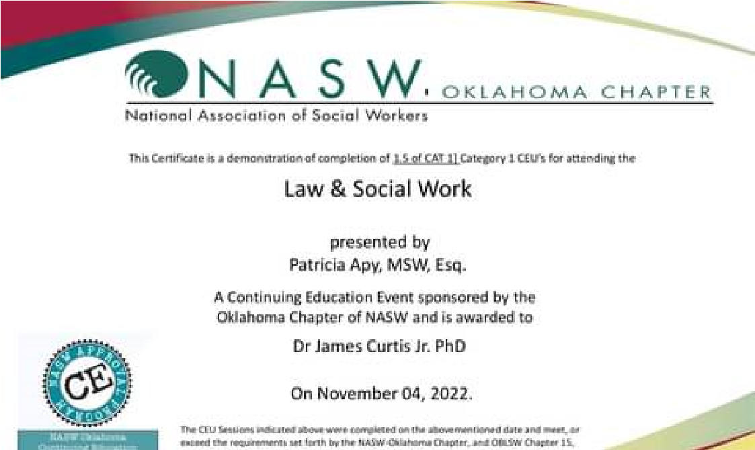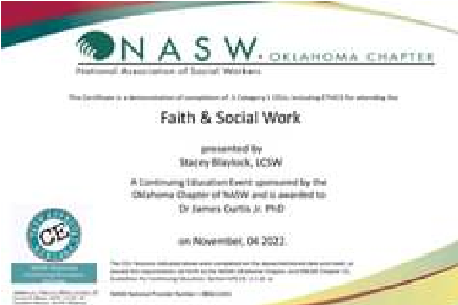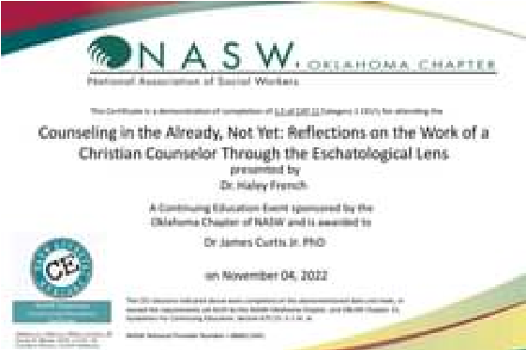
Stephen R. Barnhart
󱜳

󰛼

1 󰤥James E Curtis Jr.󰤦 󰤧
Sep 30

Religious Studies, Visiting profesorship, and candidate for the Vice President of Post-Doc
AAHEA Branch Director Dr. Curtis,Studies (Affiliate of AAHEA Branch Director).󰞋󰤊 󰟝
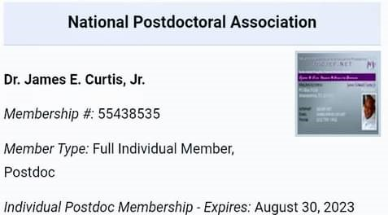

󰤥James E Curtis Jr.󰤦 󰤧Sep 27
Summer 2022, Visiting professorship Curtis, PRa 2013, Religious Studies, , visiting professorship
The 2022 Principal investigator report of Dr.
from the AAHEA, & the EF, IGDU, IGRI, JECJEF University 27-2267541.
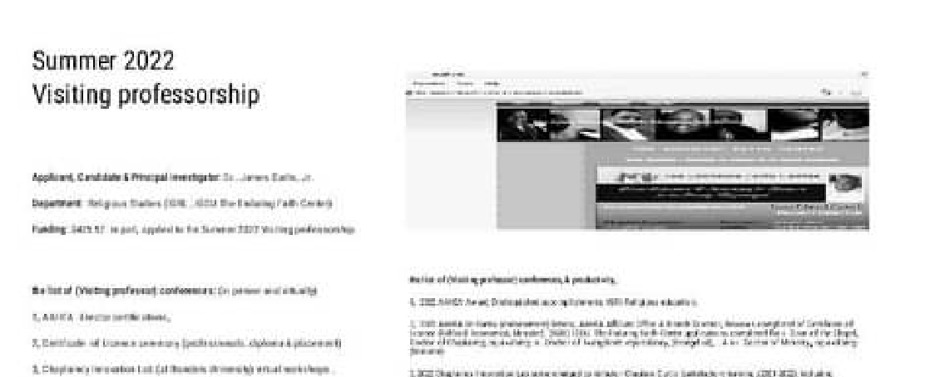
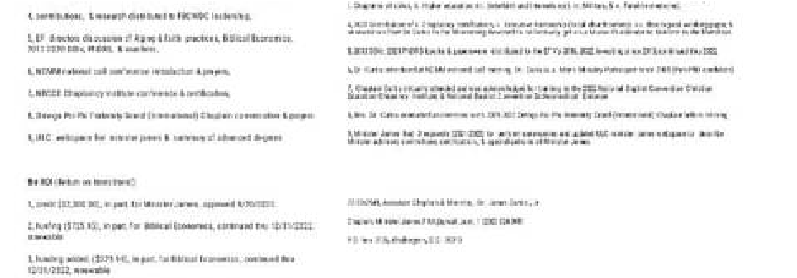󰛼
󱜳

1 󰤥James E Curtis Jr.󰤦 󰤧
9.iv.1.ASiE Rylts,'󰞋󰤊19✓,'20✓,'21✓,'22,'23
9.iv.2-9.ASIE intl Rylts1-8,'20✓,'21✓,'22,'23
9.iv.10.BiblicalEco Rylts,12/'21eBk,,H_,'22, '23
9.iv.11.BiblicalEco Rylts,12/'21(1)H._?, (2)1/"21V_?,
9.iv.12.BiblicalEco Rylts,12/'21ppr,,H_,,'22, '23
9.iv.13.Eco Rylts, '19✓,'20,✓,'21✓,'22,'23
9.iv.14.EcoHstry Rylts,'20✓,'21✓,'22,'23
9.iv.15.(Generis),GovHstry Rylts,'22,'23
9.iv.16.Insights Rylts,'21eBk, '22,'23
9.iv.17..Insights Rylts,'21ppr,'22,'23
9.iv.18.ModernPerspectives Rylts,'21eBk,'22,'23
9.iv.19.ModernPerspectives Rylts,'21ppr,'22,'23
9.iv.20.Sociology,,EcoRylts,,'22DrJamesCurtis,'23

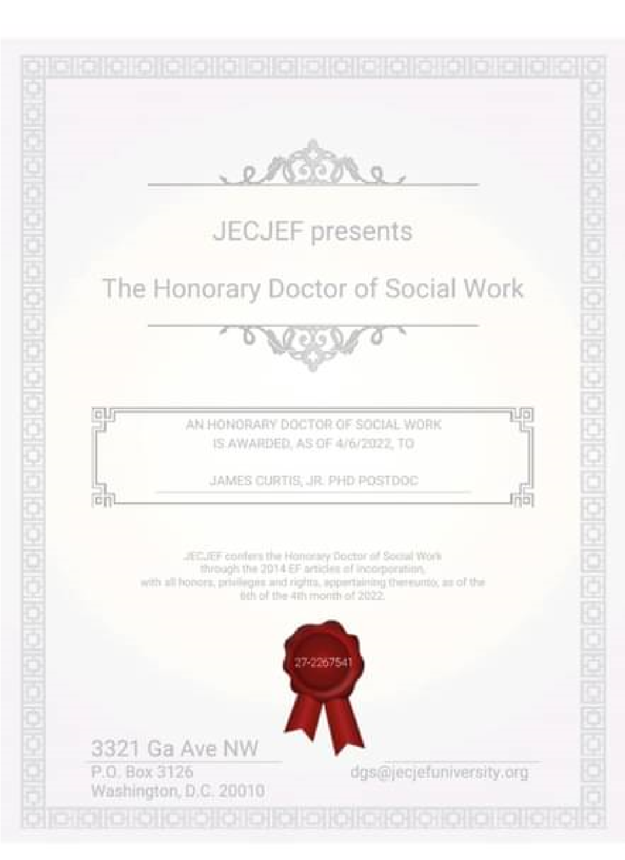
󰤥

󰤦

󰤧

James E Curtis Jr.
Aug 4
󰞋󰤊
󰟝
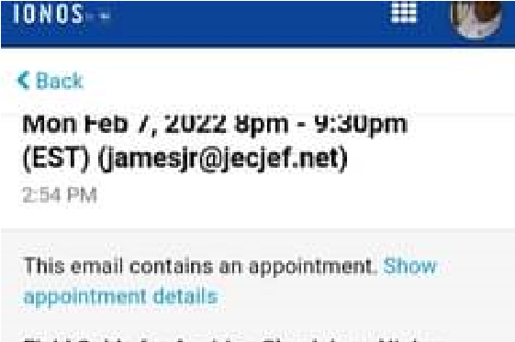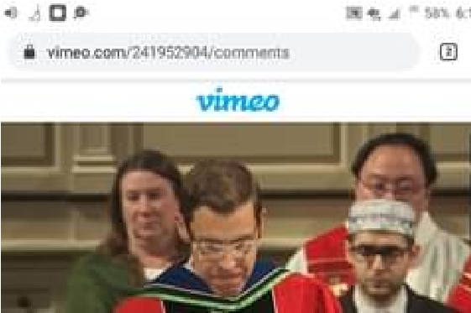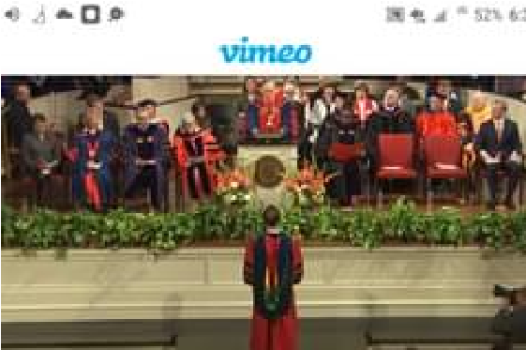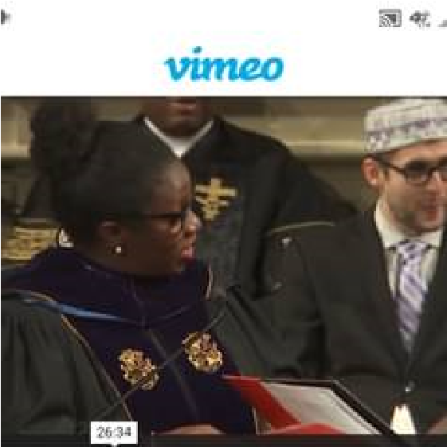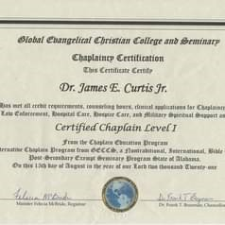󱜳
󰤥

󰤦

󰤧

Chapel Dean, , Chaplain, Dr. James Curtis Jr. (Online) Ordination Training,
Jul 12
󰞋󰤊
󰟝
+14
󰛼
󰟝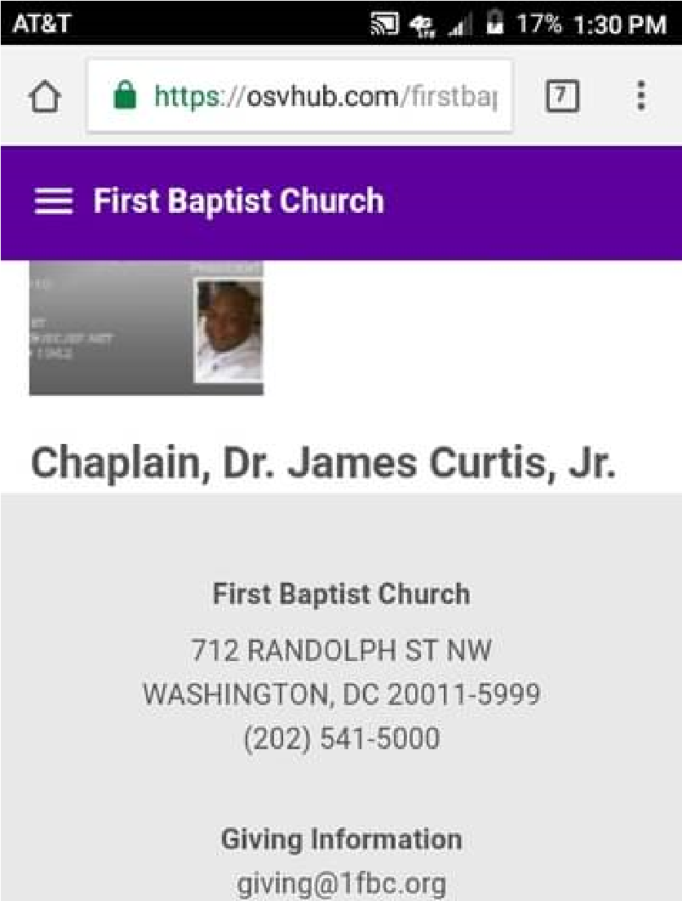
󰤥

󰤦

󰤧

James E Curtis Jr.
Jul 12
󰞋󰤊
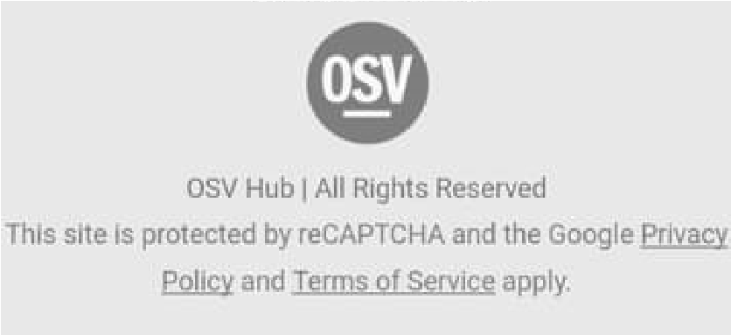 󰛼
Stephen R. Barnhart
󱜳

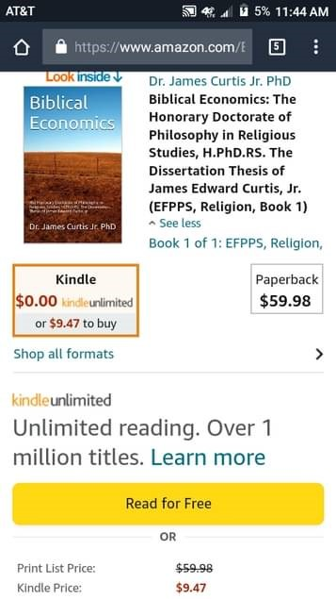󰟝
󰤥

1
󰤦

󰤧

James E Curtis Jr.
Jul 12
󰞋󰤊

󰤥

󰤦

󰤧

James E Curtis Jr.
Jun 16
󰞋󰤊
󰟝

GETORDAINED.ORG_{getordained.org} 󰛼

󱜳
James E Curtis Jr.

James E Curtis Jr.

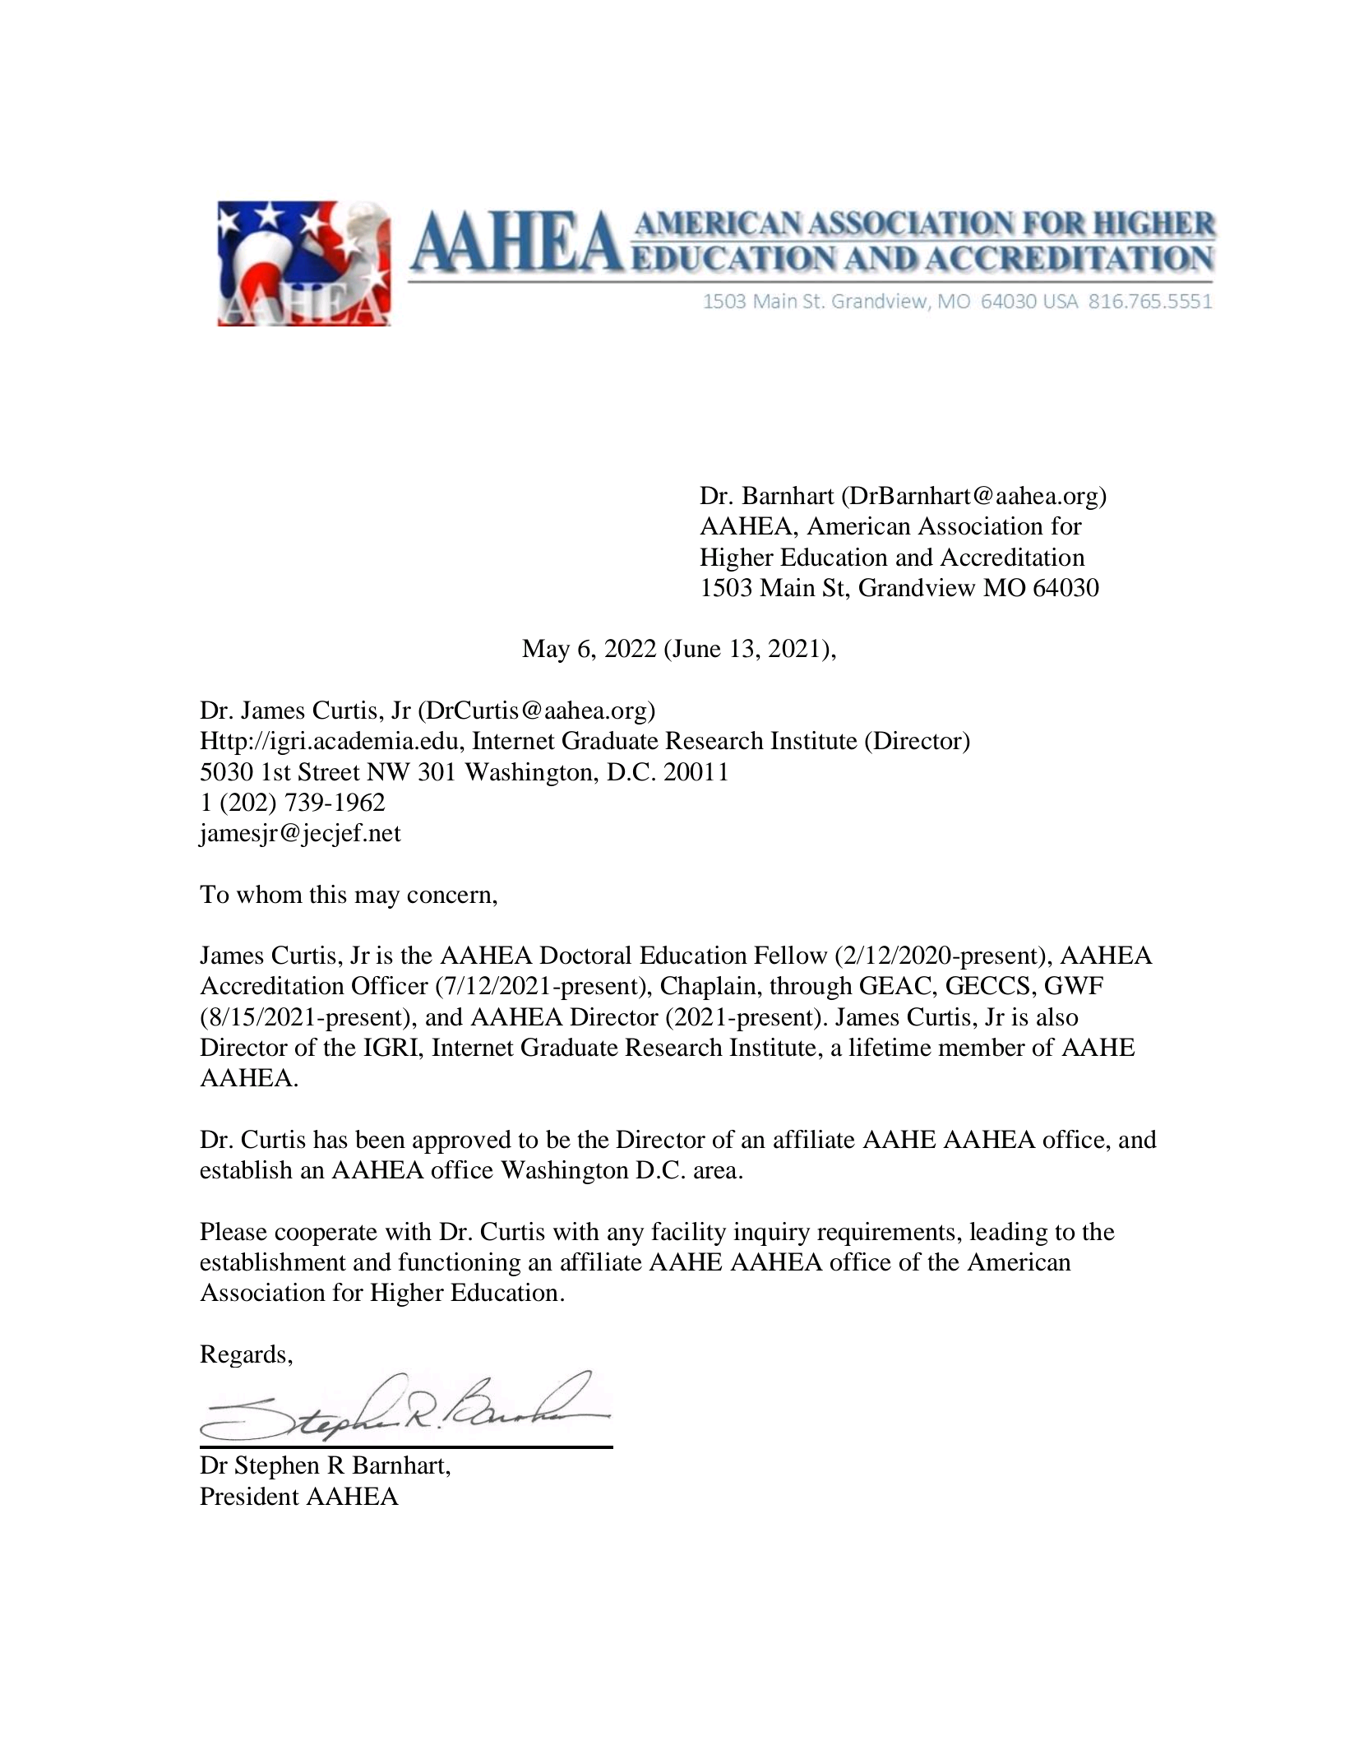

󰟝
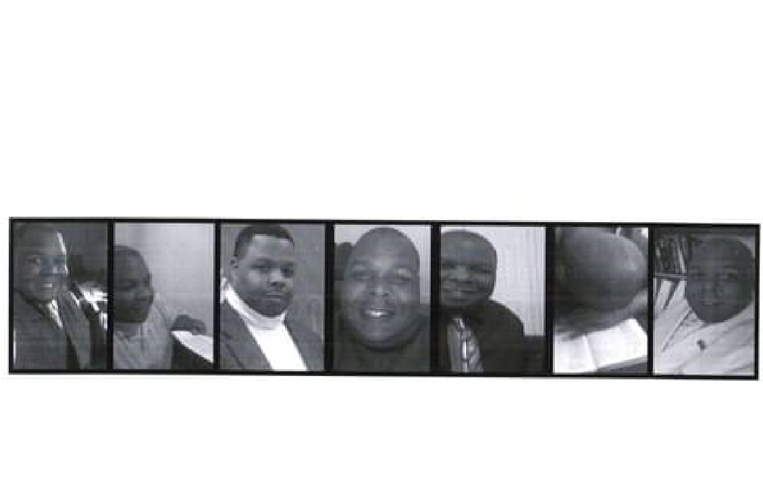
󰤥

󰤦

󰤧

James E Curtis Jr.

May 4
󰞋
󰟠
󰟝
󰤥

󰤦

󰤧

James E Curtis Jr.

May 4
󰞋
󰟠
󰟝
󱜳

󰛼

󰤥JUNE 1, 2003󰟠 󰤦
James E Curtis Jr.
Left Graduate School, Ohio State University
Completed coursework (OSU) transfered to EF, PhD, 12/31/2003.
...

󰤥Dec 1, 1998
Columbus, OH󰞋󰟠 󰤦 󰤧 󰟝
James E Curtis Jr.
Graduated from Ohio State University,
DECEMBER 1, 1998

󰤥 󰤦 󰤧
󱜳... James E Curtis Jr. 󰟝󰛼

Started School at Graduate School, OhioState University
Completed coursework (OSU) transfered to EF, PhD, 12/31/2003.
...

AUGUST 31, 1997

󰤥James E Curtis Jr.󰤦 󰤧
Aug 30, 1997Columbus, OH󰞋󰟠 󰟝
Started School at Ohio State University,
AUGUST 31, 1997

󰤥James E Curtis Jr.󰤦 󰤧
JUNE 1, 1997󰟠 󰟝
Left Job at FDIC
Department. of Research & Statistics, Research Assistant
󰤥James E Curtis Jr.󰤦 󰤧
AUGUST 31, 1996󰞋󰟠 󰟝
Started New Job at FDIC
󱜳Department. of Research & Statistics, Research
James E Curtis Jr.
󰤥James E Curtis Jr. 󰤦 󰤧 (MAY 11, 1993), MAY 11, 1993 󰟝
Left Rutgers University
Selected to the Howard-Rutgers exchange program 1993-1994. Transfered to Howard University 1994-1996.

󰤥James E Curtis Jr.󰤦 󰤧. .... 1991󰞋󰟠 󰟝
Started School at Rutgers University
Selected to the Howard-Rutgers exchangeprogram 1993-1994. Transfered to Howard University 1994-1996.

󰤥James E Curtis Jr.󰤦 󰤧
FEBRUARY 14, 1973󰞋󰙫 󰟝
Born on February 14, 1973
󰤥 󰤦 󰤧

